Stage 3 Physics: Forces and Motion in Electric and Magnetic Fields

Assignment Name: ____________________________________________ (40 marks)

- The title of the unit is Forces and Motion in Electric and Magnetic Fields. What is meant by the word ‘field’ in this instance? (1 mark)

In this instance, a ‘field’ is a region where a charged particle experiences a force on it.

- Draw the field around the following situations. (4 marks)
a. Two oppositely charged point sources b. Two parallel plates oppositely charged
negative plate on top.
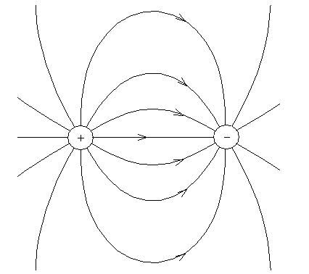

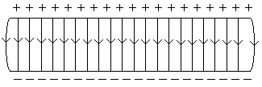

- Determine the potential difference between two plates 23.5 mm apart if an electron experiences a force of 1.50 x 10⁻¹⁵ N. (3 marks)

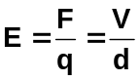
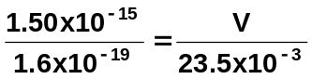
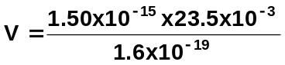
V = 220 V

- A positively charged particle with a mass of 2.55 x 10⁻¹⁷ kg and a charge that is twice that of a proton, is suspended between two plates, one above the other. What is the strength of the electric field between the plates. (3 marks)

mg = Eq
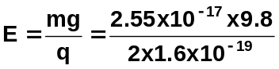
E = 781 N C⁻¹

- Two parallel plates are 2.00 cm apart in a vacuum. A proton leaves the positive plate and moves to the negative plate which has a potential difference of 180 V compared to the other plate.

a. Calculate the strength of the electric field between the two plates. (2 marks)

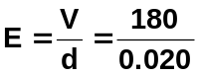
E = 9.00 x 10³ V m⁻¹

- Determine the force on the proton. (2 marks)

F = Eq
= 9.00 x 10³ x 1.6 x 10⁻¹⁹
F = 1.44 x 10⁻¹⁵ N

- Calculate the maximum speed of the proton. (4 marks)

energy = work = F x s
= .44 x 10⁻¹⁵ x 0.02
= 2.88 x 10⁻¹⁷ J

E_{k} = ½ mv²
2.88 x 10⁻¹⁷ = 0.5 x 1.67 x 10⁻²⁷ x v²
v = 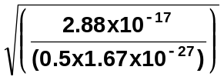
v = 1.86 x 10⁵ m s⁻¹

- A small charged particle has a charge of 3.20 x 10⁻⁷ C. If it experiences a force of 5.40 x 10⁻⁴ N west, determine the magnitude and direction of the field at this point. (2 marks)

E = 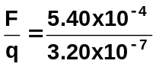
E = 1.69 x 10³ N C⁻¹ West

- An electron travelling at 8.90 x 10⁵ m s⁻¹ enters a magnetic field of 4.00 x 10⁻² T. Calculate the force on the electron when it first enters the magnetic field. (2 marks)

F = Bvq
= 4.00x 10⁻² x 8.90 x 10⁵ x 1.6 x 10⁻¹⁹
F = 5.69 x 10⁻¹⁵ N

- A proton, initially at rest, is accelerated through a potential difference of 1.60 x 10³ V and then enters a uniform magnetic field of 9.30 x 10⁻² T.

- Calculate the velocity with which the proton enters the magnetic field. (3 marks)

E_{k} = work = Vq
½ mv² = Vq
0.5 x 1.67 x 10⁻²⁷ x v² = 1600 x 1.6 x 10⁻¹⁹
v² = 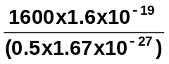
= 3.0659 x 10¹¹
v = 5.54 x 10⁵ m s⁻¹

- Determine the radius of the proton within the magnetic field. (3 marks)

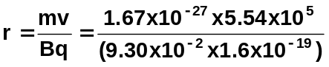
r = 0.062176

r = 6.22 x 10⁻² m

- Calculate the time for one revolution of the proton. (2 marks)

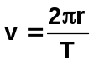
so 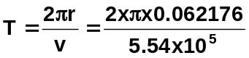
T = 7.05 x 10⁻⁷ s

- Explain the similarities and differences between electric and magnetic fields. (3 marks)

Both are dependent on the charge e.g. magnetic – Bvq; electric - 
Magnetic field: force is perpendicular to field
proportional to velocity of charged particle

Electric field: force is perpendicular to field
independent of velocity

10. a. At a university, a laboratory technician is conducting tests on the movement of electrons in a uniform magnetic field. The electrons enter the field and move in a circular path. Complete the diagram below to show the path of the fast moving electron (e₁) from the position shown in the field below. Label the path “R₁”. (1 mark)

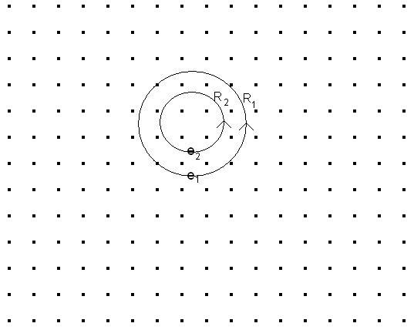
- If the technician doubles the strength of the uniform magnetic field, and keep all other conditions constant, draw the path traced out by electron (e₂) above. Label its path “R₂”.
(2 marks)

- Determine the ratio of the two radii traced out by e₁ and e₂. (3 marks)

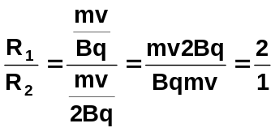
R₁ = 2R₂ or R₂ = ½ R₁

